

2021



SUPERVISED BY: SIR SYED ASAD

GROUP MEMBERS: HAMZA ,RAJA HAMZA , SULAYMAN

Total 164 Pages

**Table of Contents**

Certificate of Completion 6

Acknowledgement 7

Project Synopsis 8

Functional Requirement 9

Problems Statement: 11

Proposed System 12

Hardware and Software Requirements 13

Website Features 14

Flow diagram 15

User Guide 16

• Homepage (landing Page) 16

• ALL PORDUCTSS 17

• SALES 18

➢ COOKWARE: 20

➢ REFRIGERATION: 21

➢ APPLIANCES: 21

➢ FOOD STORAGE: 22

COMPARE PRODUCTS: 23

SUB-DIVISIONS OF COOKWARE: 24

o COOKING POTS: 24

o COOKING PANS: 24

o COOKWARE SETS: 25

o HANDI’S 25

o KADAI’S(KARAHI) 26

o GRILL PANS 26

o TAWAS 27

o EGG POACHERS 27

o STEAMERS 28

SUB-DIVISIONS OF REFRIGERATION: 29

o FREEZERS 29

o REFRIGERATOR 29

SUB-DIVISIONS OF APPLIANCES: 30

o BLENDER 30

o BREAD MAKER 30

o COFFEE MAKER 31

o ICE CREAM AND SORBET MAKER 31

o ELECTRIC KETTLE 32

o FOOD CHOPPER 32

o TOASTERS 33

SUB-DIVISIONS OF FOOD STORAGE: 34

o FLASK 34

o SPICE JARS 34

o STORAGE BAGS 35

o LUNCH BOXES 35

o VACCUM BOTTLES 36

Developer’s Guide 37

COOKWARE 37

APPLIANCES 38

FOOD STORAGE 38

COMPARE PRODUCT 39

Task Sheet 41

# *Certificate of Completion*

This is to certify that **HAMZA, RAJA HAMZA** and

**SULAYMAN** have successfully completed their ACCP Semester I E-Project.

Submitted to: **Aptech Computer Education**

On

**SEP 1th, 2021**

# *Acknowledgement*

First of all we would like to thank Almighty Allah for giving us strength and ability to complete this project.

And then, we would like to express my special thanks of gratitude to our teacher **Sir ASAD** who guided us on the project *Kitchen Appliances*, which also helped us in doing a lot of new learning and we came to know about so many new things we are really thankful to him.

Lastly, we would also like to thank our parents and friends who helped us a lot in finalizing this project within the limited time frame. We also express our sincere gratitude to E-Project team from Aptech Head Office, for their valuable guidance and support for the completion of this project. We earnestly hope that this project will provide all the necessary information required by the user to fulfill his/her inspiration. However, suggestion and Feedbacks for improvements will be thankfully welcomed & acknowledged*.*

# *Project Synopsis*

TASHA- *the home store* is Branded Company famous for home kitchen appliances. It provides collection of n number of appliances with different category to match the fast life of the generation. The Tasha group of companies had made huge profit in the year 2013. In order to enhance its business, we’re developing their site.

# *Functional Requirement*

1. Home Page
2. ALL PRODUCTS
3. SALES
4. Categories
   1. Cookware
   2. Appliances
   3. Refrigeration
   4. Food Storage
5. With Sub- Categories Of:
   1. Cookware

Cooking Pots

Cooking Pans

Frying Pans

Handis

Kadais

Grill Pans

Tawas

Egg Poachers

Steamers.

* 1. Refrigeration

Refrigerators

Freezers

* 1. Appliances

Blender

Bread Maker

Coffee Maker

Ice-Cream And Sorbet Makers

Electric Kettles

Food Choppers

Toasters.

* 1. Food Storage

Flask

Spice Jars

Storage Bags

Lunch Boxes

Vaccum Bottles.

1. Support Links Like..
   1. About Us
   2. Manuals
   3. Our Stores
   4. Contact Us
2. Store Locators

# *Problems Statement:*

TASHA- *the home store* is Branded Company famous for home kitchen appliances. It provides collection of n number of appliances with different category to match the fast life of the generation. The Tasha group of companies had made huge profit in the year 2013.

# *Proposed System*

To overcome problems, it is proposed to develop a website which includes their main navigation pages of all the products which they want to sell.

So in this way they can easily enhance their business and expand their sale and services all over the world.

# *Hardware and Software Requirements*

**Hardware**

* A minimum computer system that will help you access all the tools in the courses is a Pentium 166 or better
* 64 Megabytes of RAM or better

**Software**

* Notepad/HTML editor
* Dreamweaver
* IE 5.0/ Netscape 6.0

# *Website Features*

This website TASHA-the home store, contains almost all of the kitchen machines and appliances. So, the development of this website gives people to purchase their kitchen equipment by single click.

This site contains pictures and description along with their prices of all those products which they were selling in their store.

# *Flow diagram*

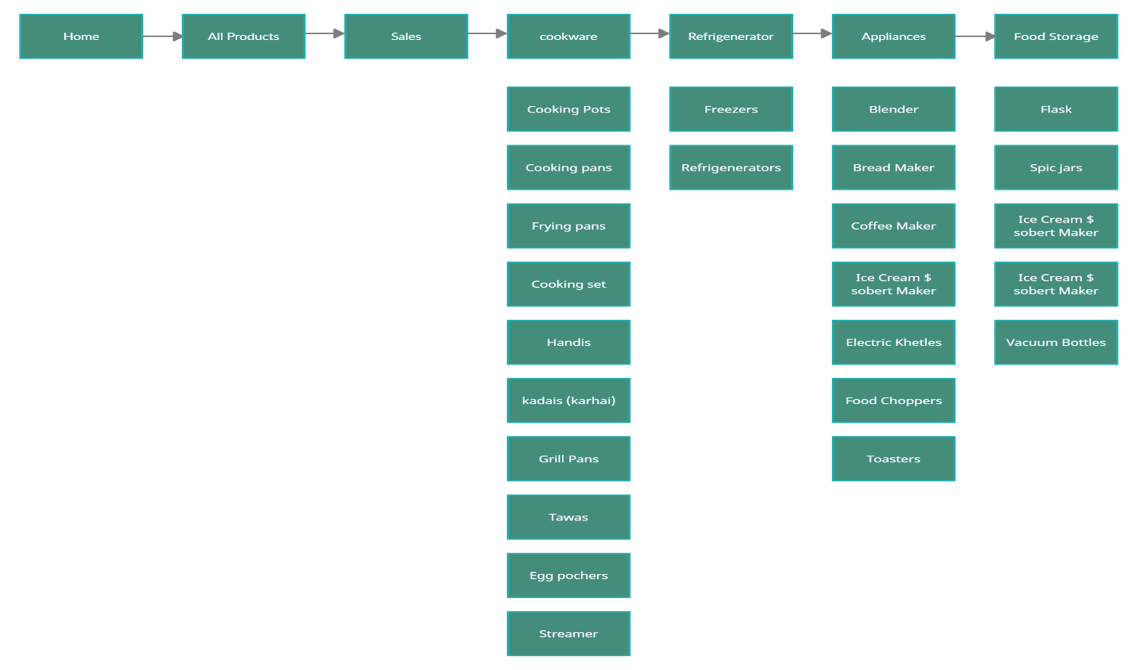

# *User Guide*

* *Homepage (landing Page)*

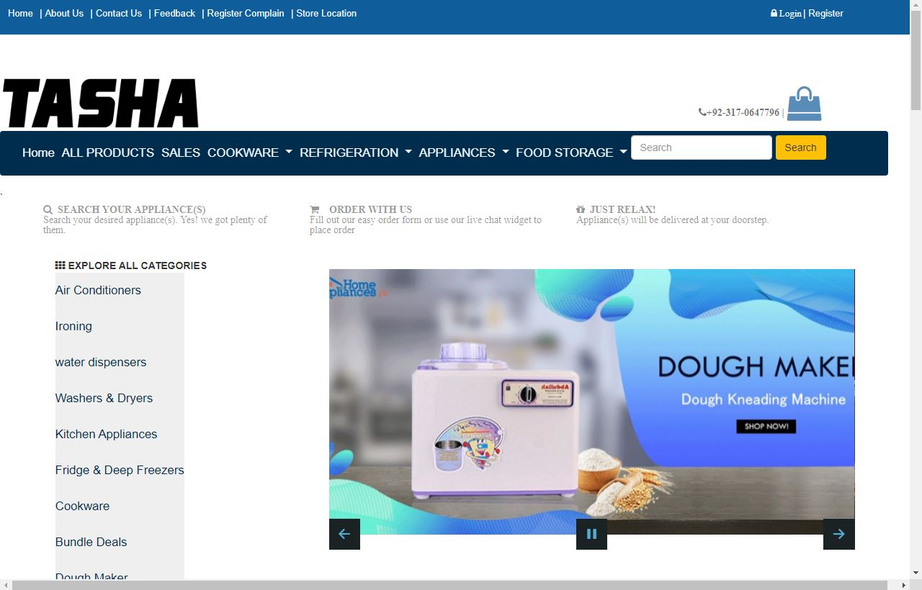

* *ABOUT US*

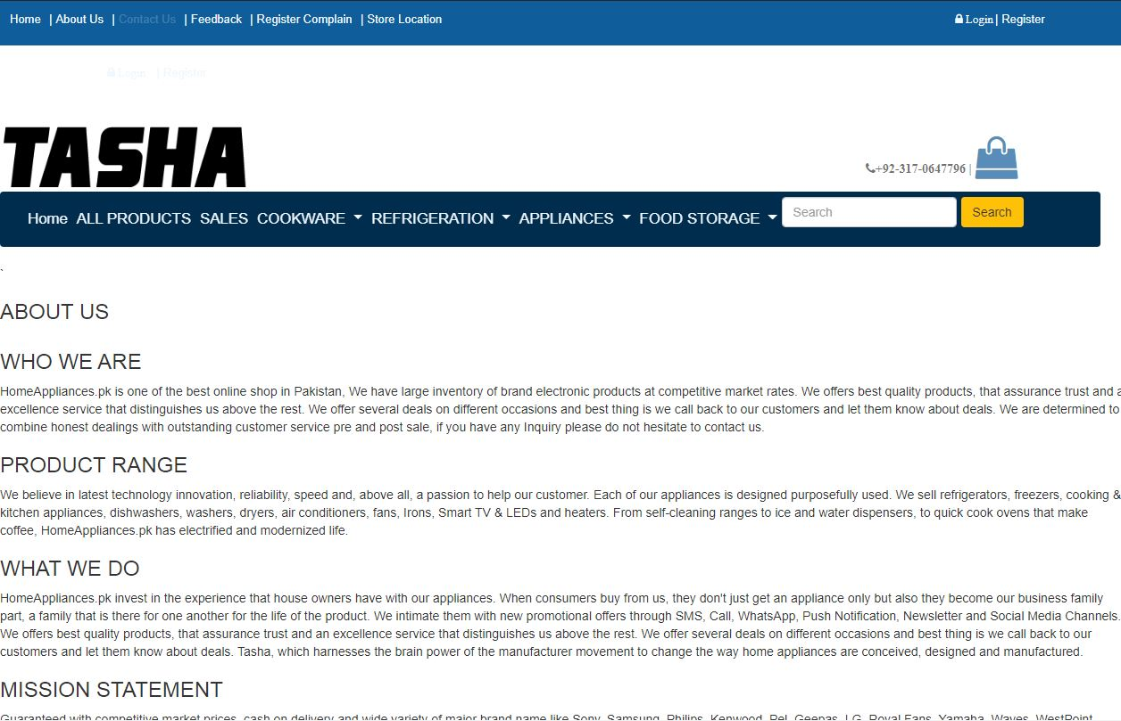

* *SALES*

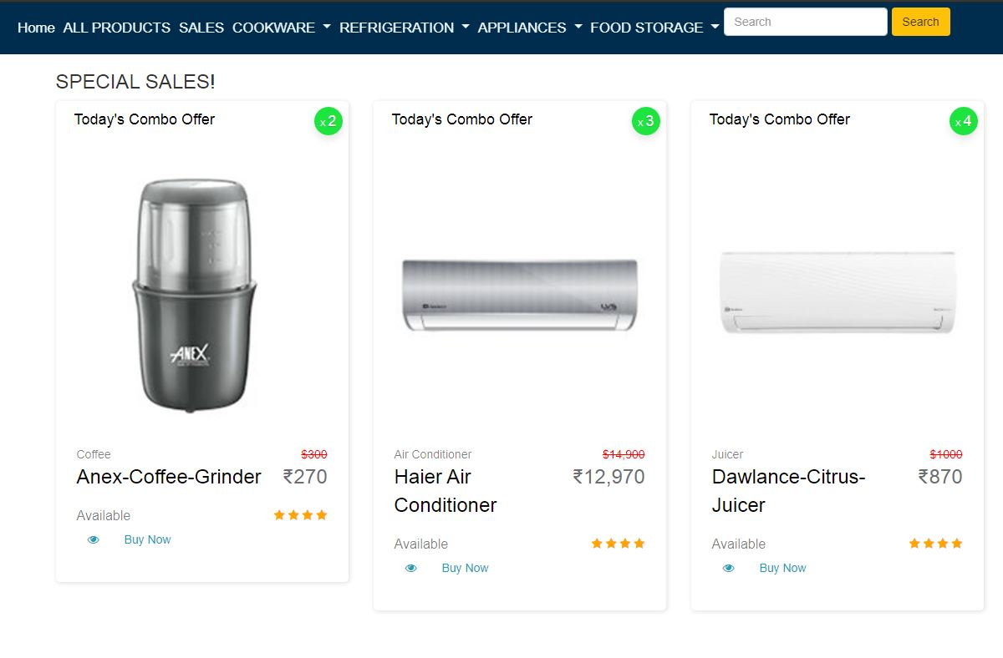

*STORE LOCATION*

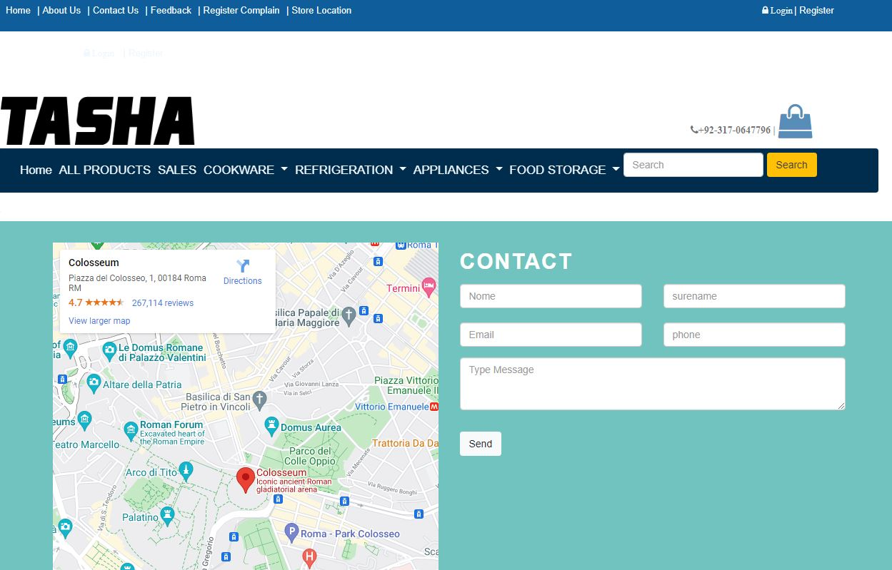

*­­­­­*

* *COOKWARE:*

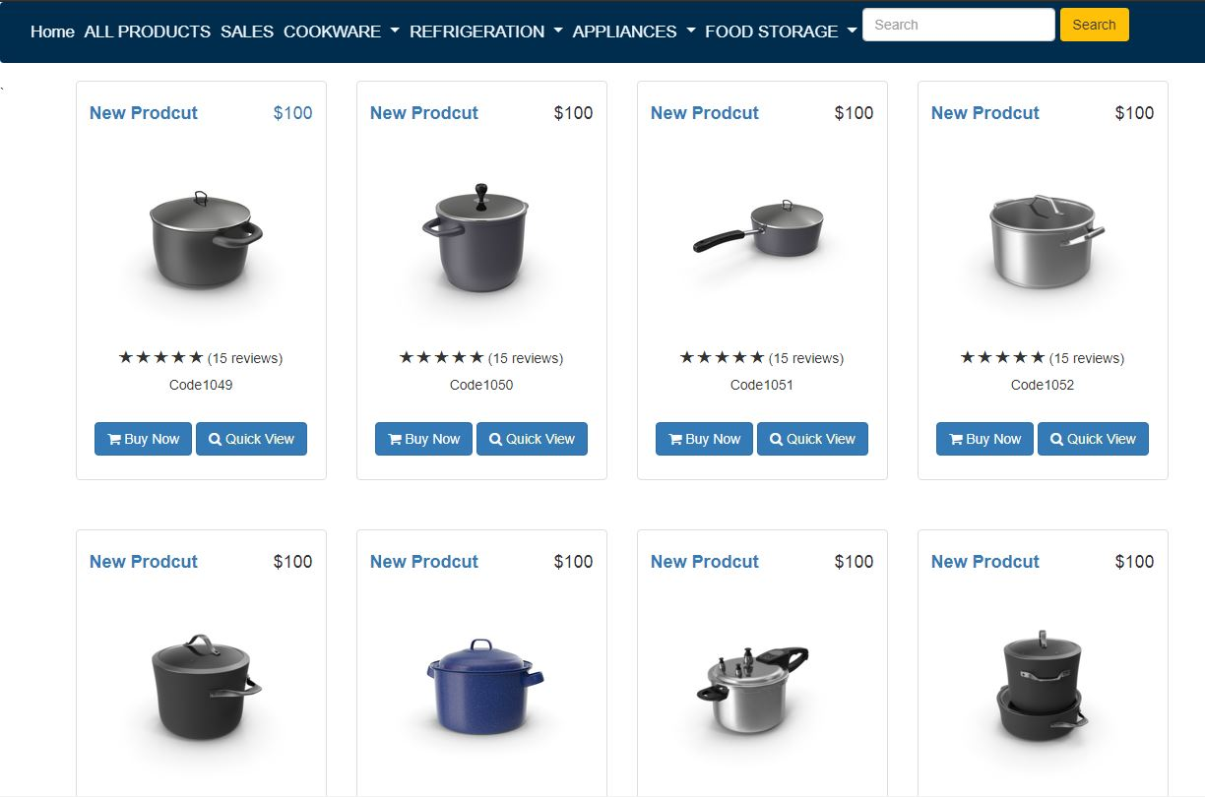

* *REFRIGERATION:*

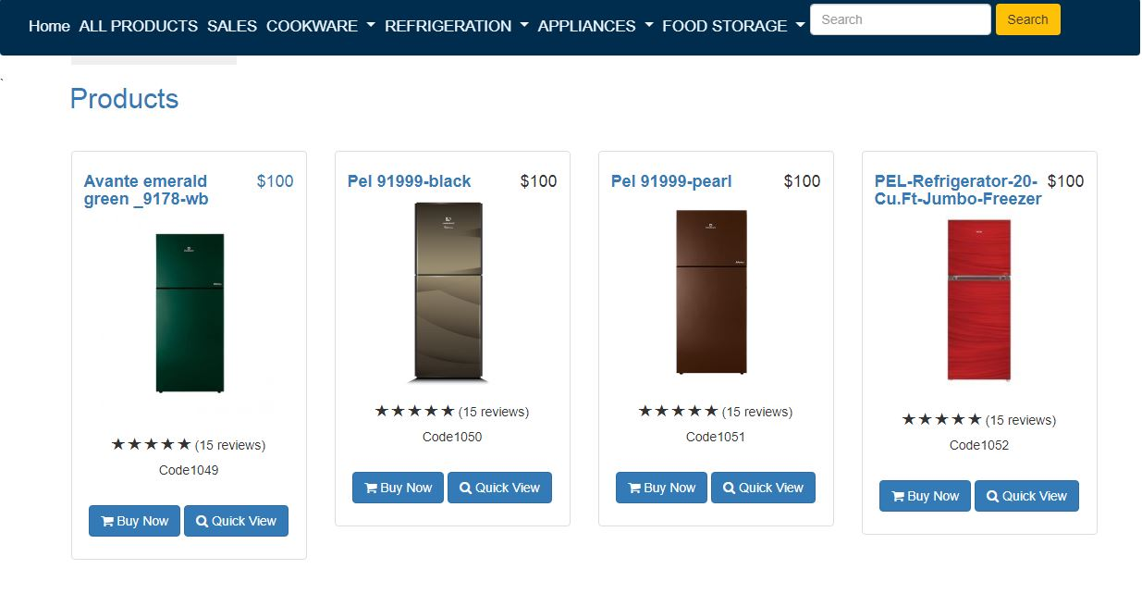

* *APPLAINCES:*

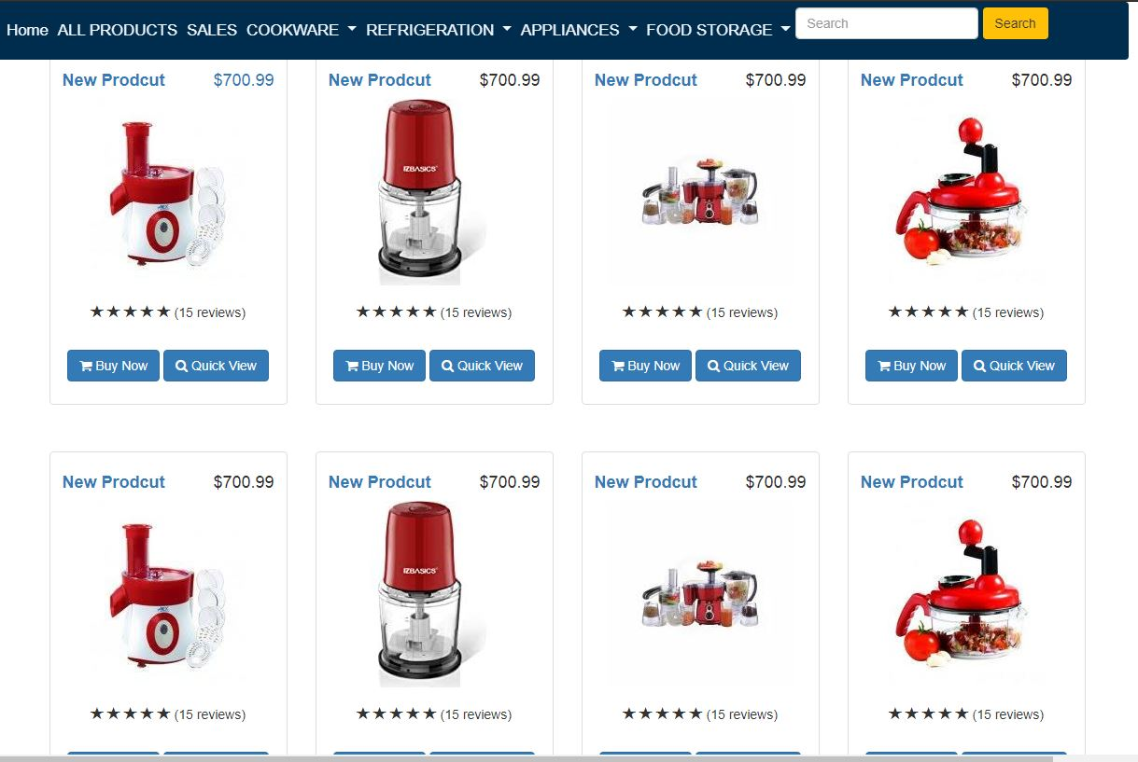

* *FOOD STORAGE:*

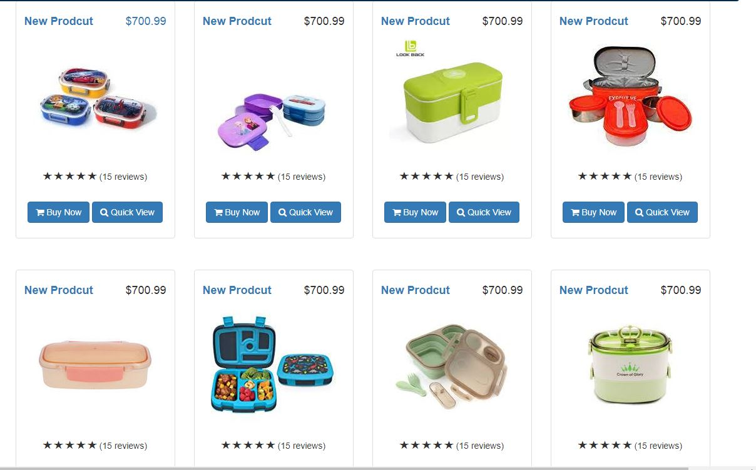

### *login:*

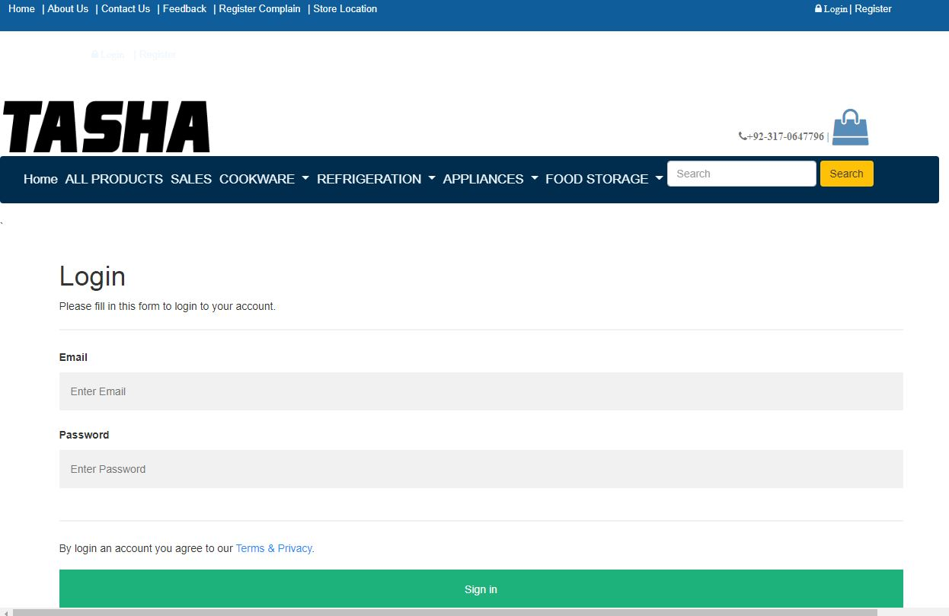

### *Register:*

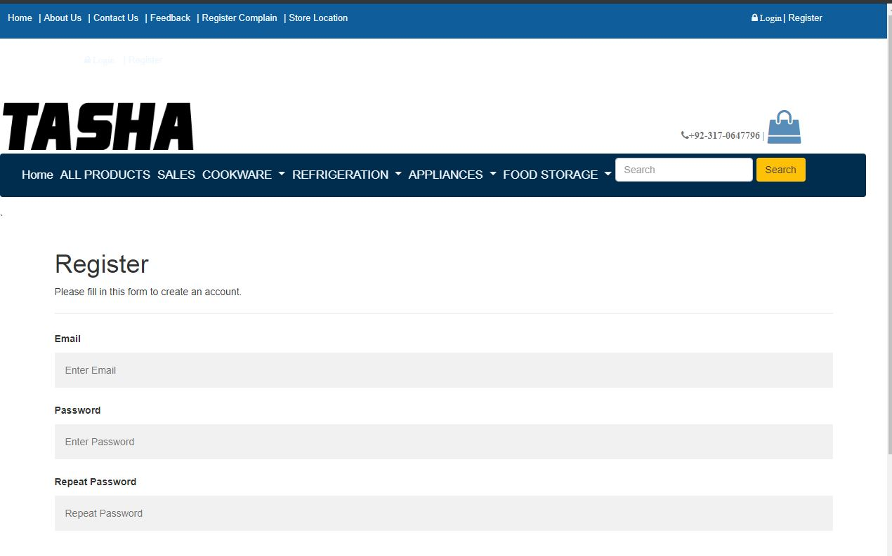

*Developer’s guid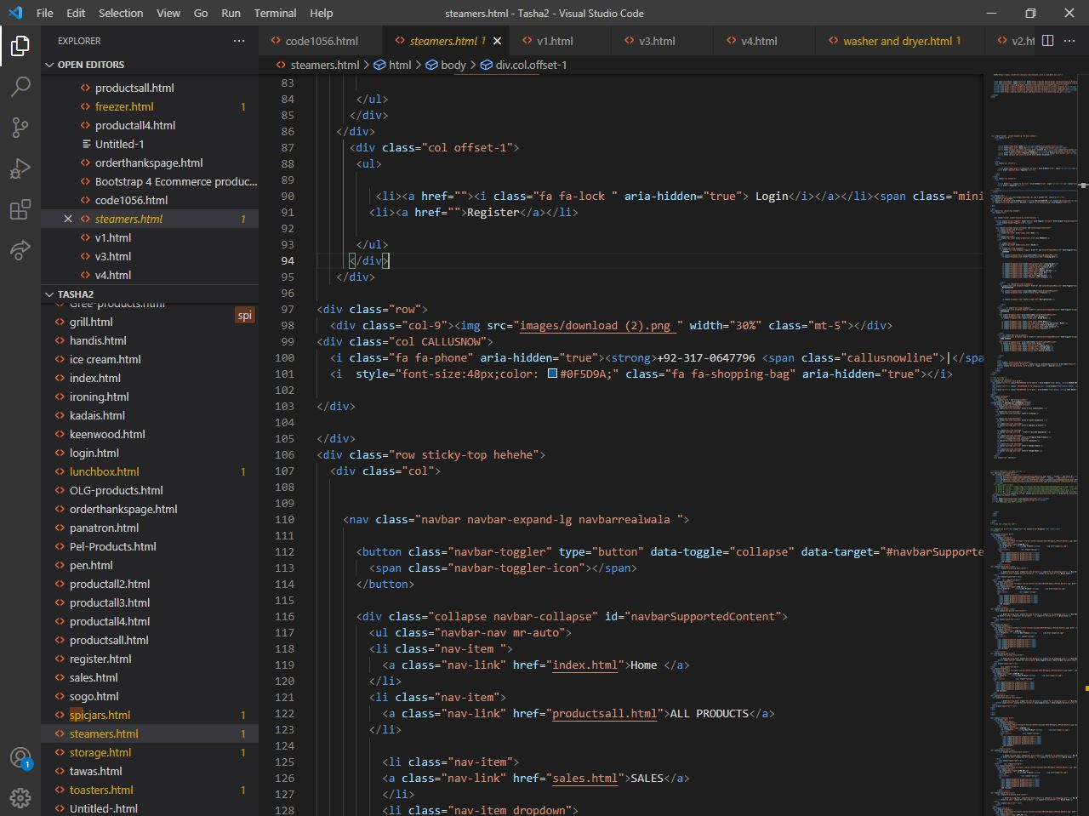*

*Task Sheet*

|  |  |  |  |  |
| --- | --- | --- | --- | --- |
| Project Ref. No. | | Project Title | Date of Preparation of Activity Plan | |
| S.No. | Task | **Kitchen Appliances** | Actual Days | Status |
| 1 | Analysis | 1 | OK |
| 2 | Design | 2 | OK |
| 3 | Development | 5 | OK |
| 4 | Testing | 1 | OK |
| 5 | Documentation | 1 | OK |